**Activity 11.3 - Mohammed Abdin**

**Submission Instructions:**

Your submission for this assignment should be a Word document that includes the following screenshots, each labeled for the step that the screenshot represents:

1. A screenshot of VS Code showing that you downloaded and opened the file [Activity 11.3.zip](https://classroom.emeritus.org/courses/10605/files/3006867/download).

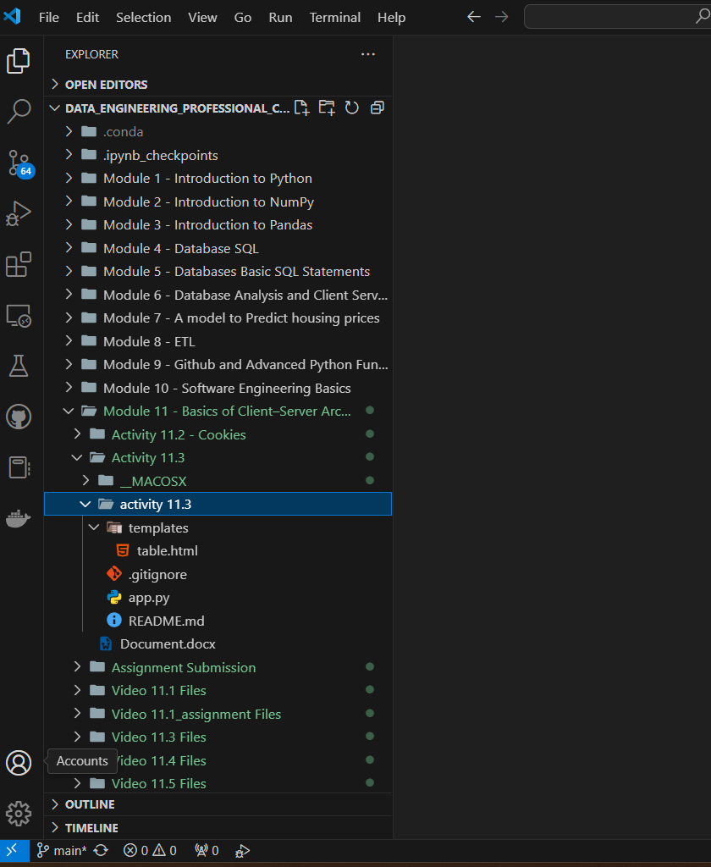

1. A screenshot showing that you opened the app.py file correctly.

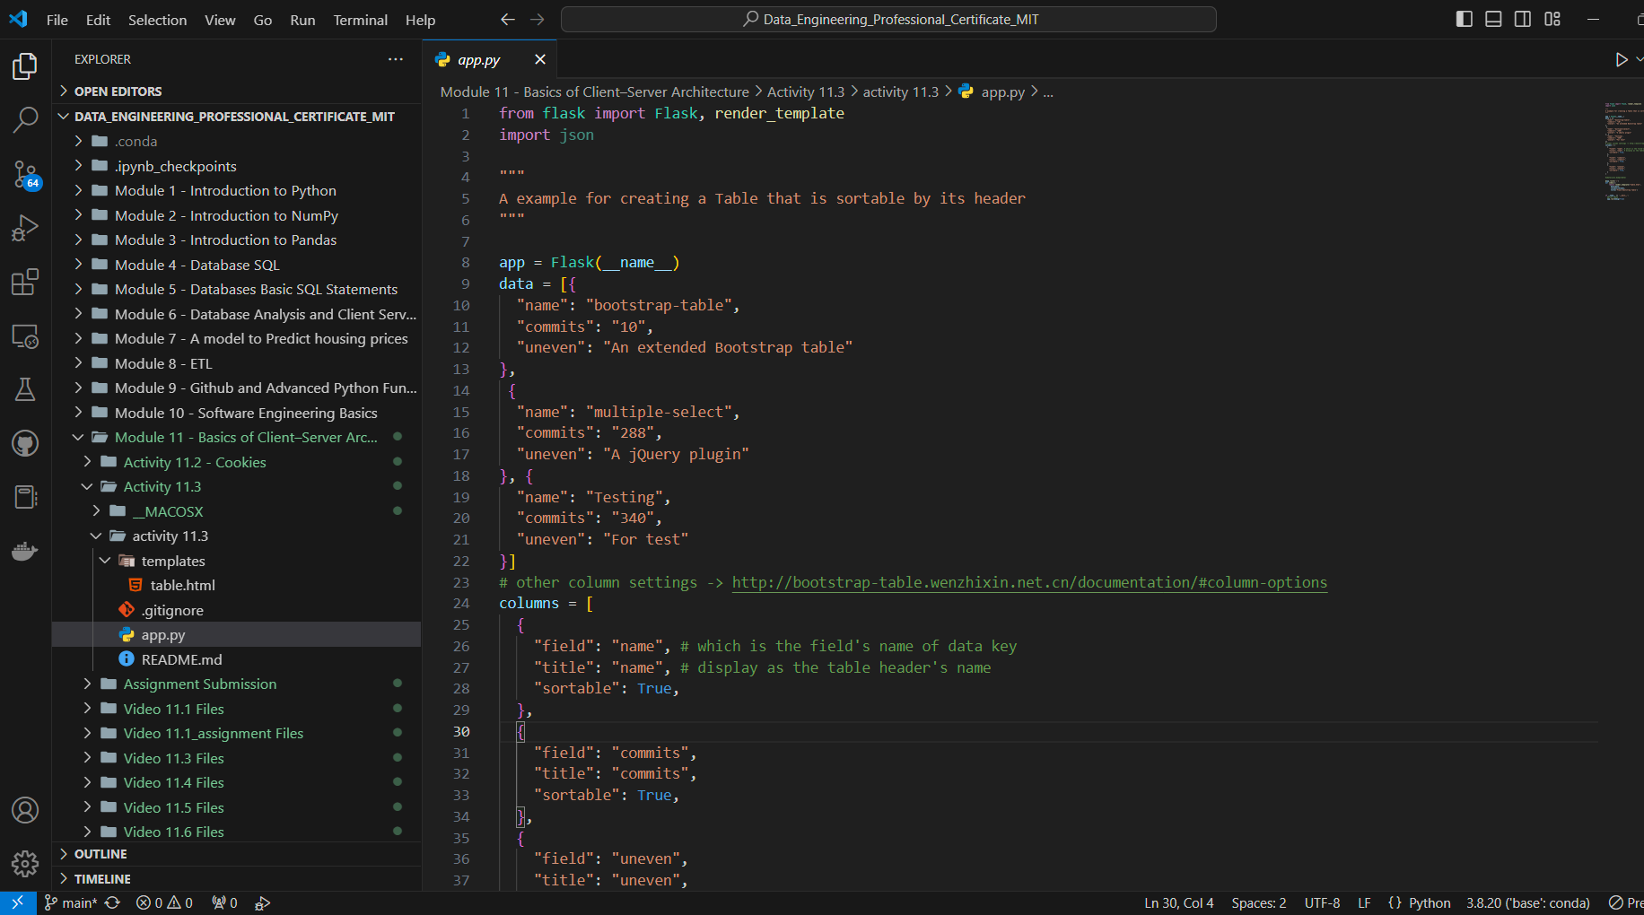

1. A screenshot of the table defined in the app.py file by navigating to localhost/5000.

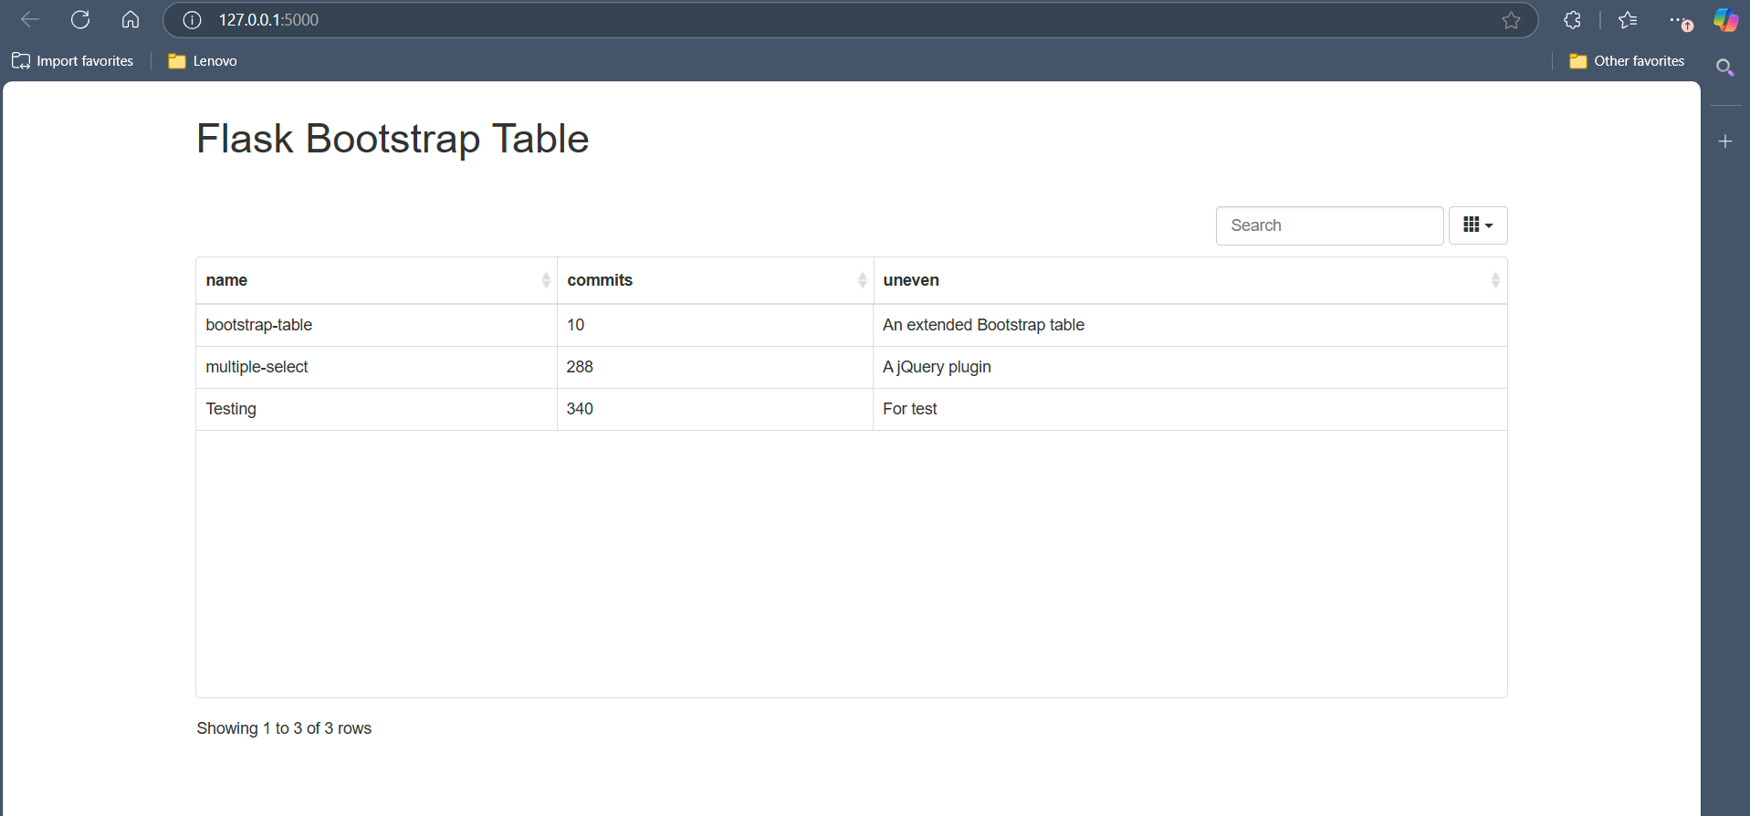

1. Screenshots of the edited app.py file to show that you edited the entries in the table.

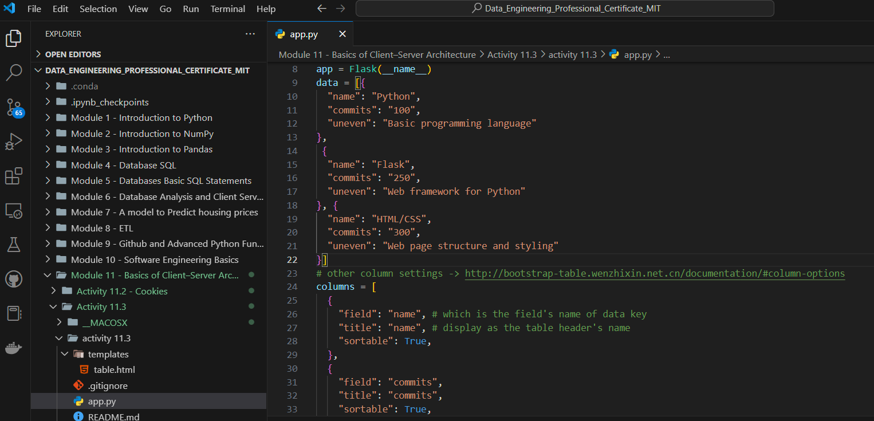

1. A screenshot of the modified table defined in the app.py file by navigating to localhost/5000.

